# Kali Linux operating system within a VirtualBox environment

**Task 1: Creating a Kali Linux Virtual Machine (VM)**

* Open VirtualBox and click on the "New" button to create a new VM.
* Provide a name for your VM (e.g., "Kali Linux").
* Select "Linux" as the type and "Debian (64-bit)" as the version.
* Allocate memory (RAM) to your VM. Recommended: at least 2 GB.
* Create a virtual hard disk for your VM. Allocate at least 20 GB of storage space.
* Follow the installation wizard to configure additional settings, such as network adapters and attach the Kali Linux ISO image for installation.
* Complete the Kali Linux installation within the VM.
* 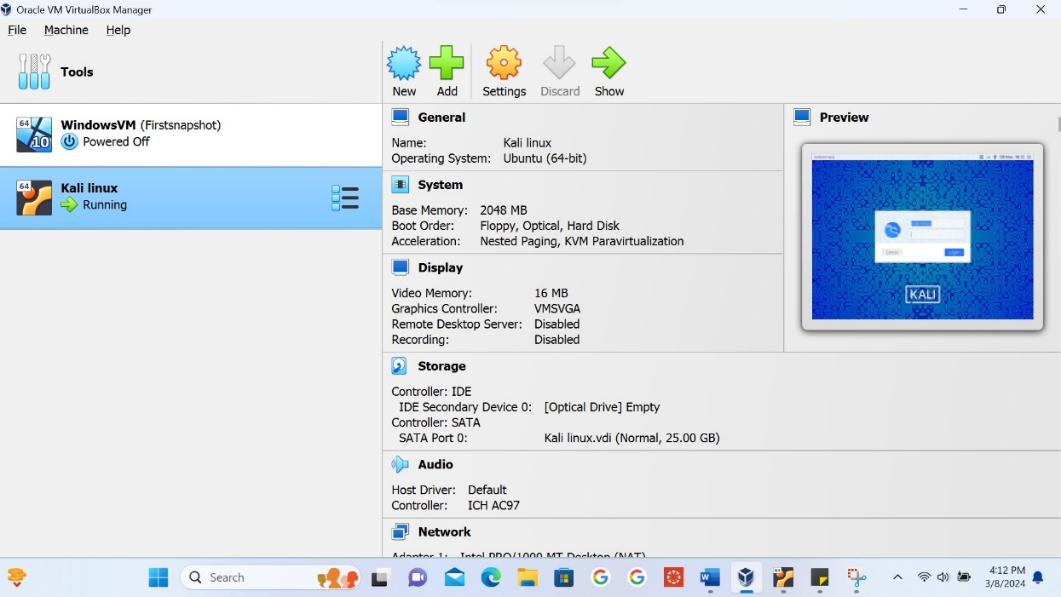

**Task 2: Initial Configuration and Login**

* After Kali Linux installation, set up the basic configurations, including user accounts and password.
* Log in to your Kali Linux VM using the credentials you created.
* 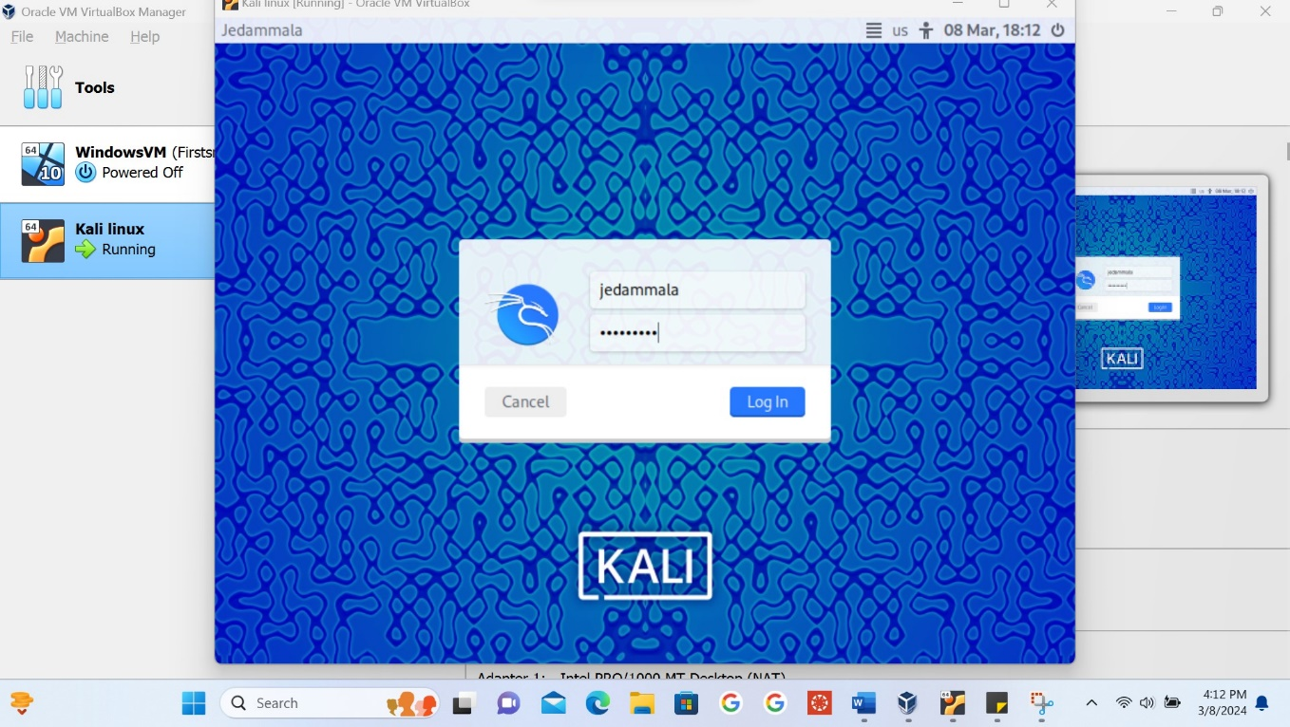

**Task 3: Introduction to Linux Terminal**

* Open the Linux terminal within your Kali Linux VM.
* Execute the following introductory Linux commands and explain their purpose:

1. pwd: Print the current working directory.
2. ls: List files and directories in the current directory.
3. cd: Change the current directory.
4. mkdir: Create a new directory.
5. touch: Create an empty file.
6. nano or vim: Open a text editor to create or edit a file.
7. cat: Display the contents of a file.

**Task 4: Basic File Operations**

* Create a new directory named "LabFolder."
* Navigate to the "LabFolder" directory using the cd command.
* Create a text file named "hello.txt" using the touch command.
* Use a text editor (e.g., nano or vim) to open "hello.txt," write a greeting message, save the file, and exit the editor.

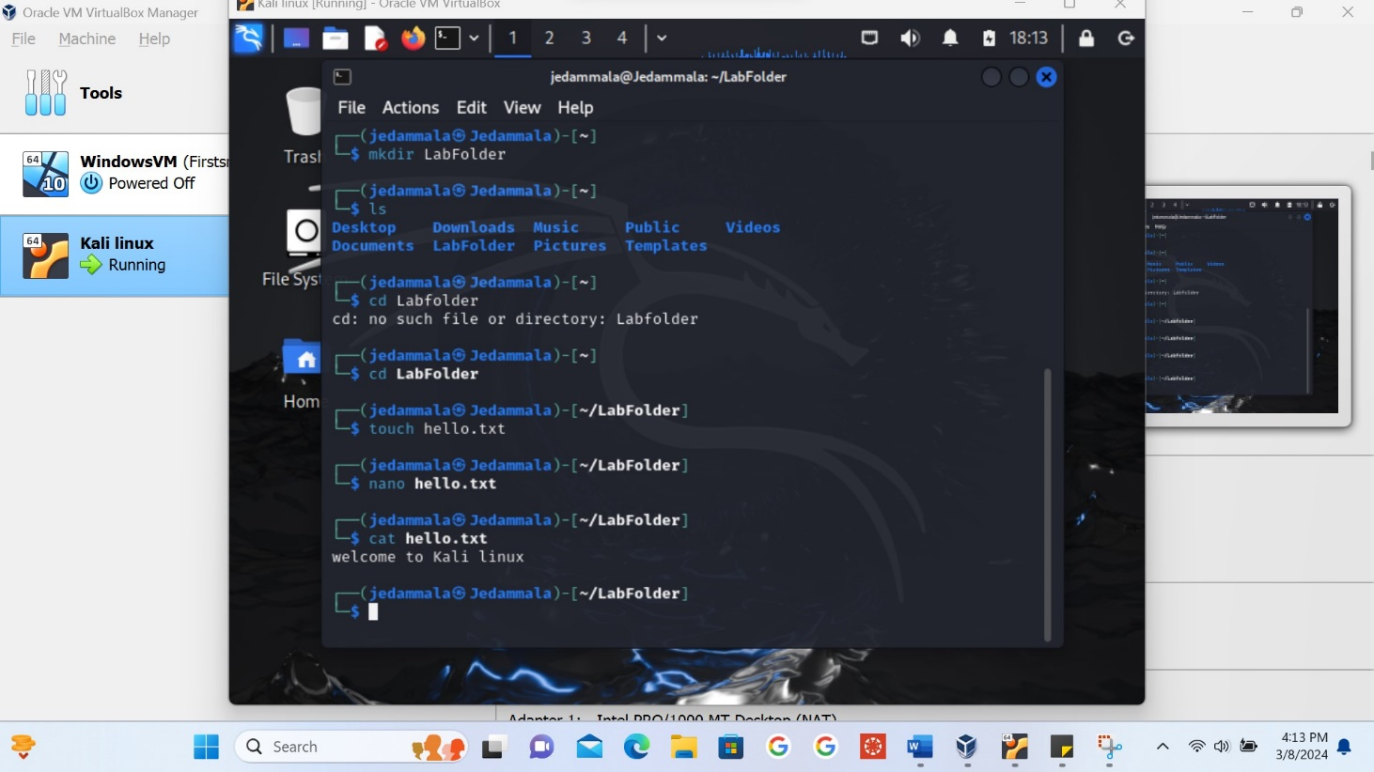

**Task 5: Submission**

Setting up a Kali Linux VM typically involves downloading the ISO file, creating a new virtual machine in a hypervisor like VirtualBox or VMware, and installing the OS. This process introduces users to VM management concepts and installation procedures.Upon booting into Kali Linux, users are greeted with the graphical user interface. Navigating through menus, exploring pre-installed tools, and understanding the layout familiarizes users with the Linux environment.The heart of any Linux system lies in the terminal. Executing basic commands like ls, cd, mkdir, helps users understand file system navigation, manipulation, and permissions. It's an opportunity to grasp fundamental concepts such as directories, files, permissions, and processes.

setting up a Kali Linux VM and executing basic Linux commands is not merely a technical exercise; it's an immersive learning journey. It cultivates essential skills in system administration, security while fostering a deeper understanding of the open-source ecosystem and its vibrant community.